🚀 Cohere API Key Setup Instructions

What you’ll end up with
By the end, you will have:
- A Cohere account
- A Cohere Trial API key copied and saved somewhere safe (you’ll use this in our n8n Cohere Rerank node)
Cohere creates a Trial API key automatically when you create your account, and it’s available in the dashboard under API Keys.

Important safety note (please read)
Your Cohere API key is like a password:
- ✅ Keep it private
- ❌ Do not post it in Slack/WhatsApp/email threads
- ❌ Do not paste it into screenshots you share
- ❌ Do not commit it to GitHub
If you ever accidentally expose it, delete/revoke it immediately in the Cohere dashboard and create a new one (same API Keys page).

Step 1 — Create a Cohere account (first-time users)
- Open the Sign up page: https://dashboard.cohere.com/welcome/register
- Choose one sign-up method (any is fine):
  - Continue with Google
  - Continue with Github
  - Or sign up with Email + Password
- If you choose Email + Password:
  - Click into the Email field → type your email address
  - Click into the Password field → create a password
  - Click Sign up
- Email verification (if prompted):
  - Check your inbox for a verification email
  - If you don’t see it, check Spam / Promotions
  - Click the verification link in the email and return to the dashboard
Expected result: You can access the Cohere dashboard.
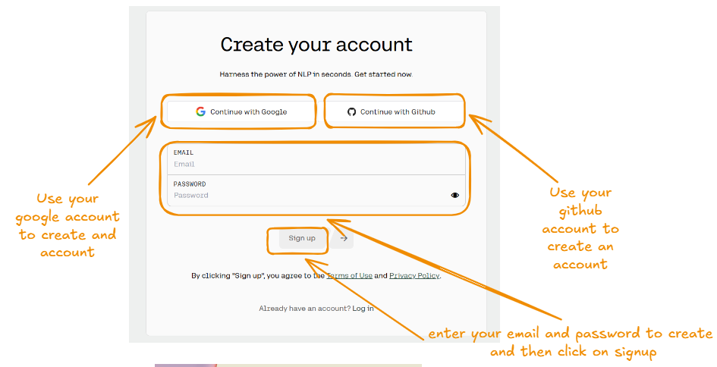
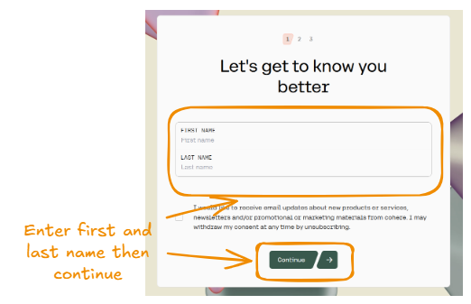

Step 2 — Go to the API Keys page
- Make sure you are logged in:
- Open the API Keys page directly using the link below:
  - https://dashboard.cohere.com/api-keys
- On the API Keys page by clicking on "API Keys” option on the right side menu,
- You should see at least one key:
  - Cohere typically creates a Trial API key automatically when your account is created
  - Cohere describes two types of keys: Trial/Evaluation and Production
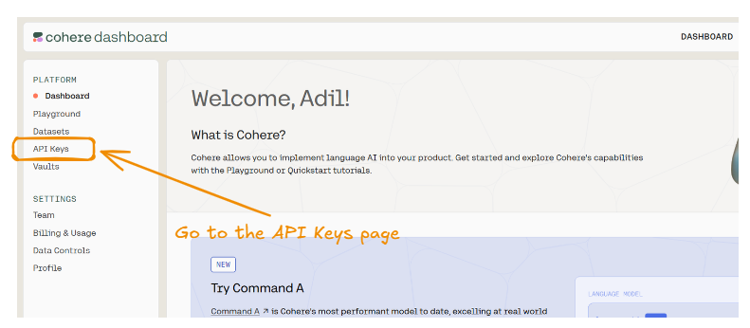

Step 3 — Copy your Trial API key
- On the API Keys page:
  - Look for a key labeled something like Trial / Evaluation
  - You’ll typically see a copy icon next to it (or a “Copy” button)
- Click Copy
  - Paste the key into a temporary safe place immediately (example: a password manager note)
  - This reduces the risk of losing it or copying the wrong thing
✅ What the key looks like: a long random string of letters/numbers.
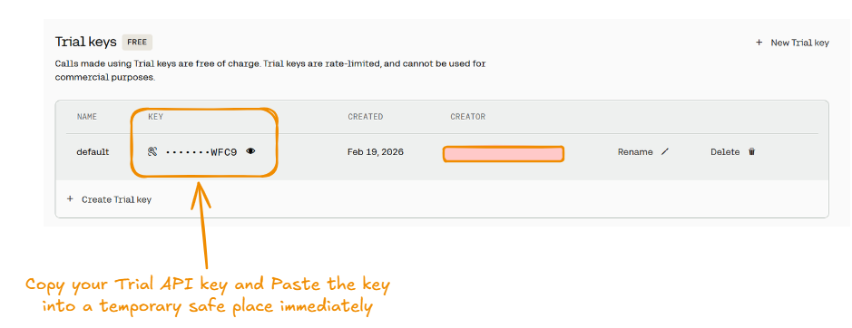

Step 4 — (If needed) Create a new Trial key
In some accounts, you’ll already have a Trial key and won’t need this. But if you don’t see one, or you want a key specifically named for this course:
- Still on the API Keys page, look for a button like:
  - New Trial key, Create API key, or similar wording
(UI text can change slightly over time.)
- If it asks for a name, use something clear like:
  - n8n-rag-class
  - rerank-assignment
  - dev-key
- Click Generate/Create
- Copy the newly generated key and store it safely.
